.

**IB Psychology**

**HCPS Image**

The Internal Assessment



**IB Psychology Internal Assessment (IA)**

***What is a Psychology IA?***

You will find an existing psychology experiment that manipulates an Independent Variable (IV) and replicate it. It is essential that your research is based on an experiment that has been published. You should not invent something of your own. You are not creating a ground-breaking, earth-shattering new theory--but you will modify a published study. You are demonstrating a solid design and coherent, in-depth understanding of the results.

Then write a typed report according to the IB guidelines and format listed here. This is an outline for the stages of your research as well as what to do at each stage. Be sure to pay attention to the due dates for each section.

***Getting Started***

The first step is to choose a SIMPLE experiment to replicate. Don’t suffer from *Parsimoniophobia*: the fear of simplicity. The success of your experiment depends on finding appropriate study for your research.

Find the experiment first. Do not choose a topic and then spend hours looking for experiment. Do not choose a study that is too obscure. Find a simple study that interests you. Don’t let the dry, boring titles fool you. The actual experiment may be more fun than it sounds.

You can find your experiment online as well as in textbooks, journals, articles, and databases. Avoid too many Internet sources. You can “tree” backwards to other sources once you find your study (through Wikipedia, books, journal articles, etc). Consider databases such as the Social Sciences Citation Index (SSCI), Smithsonian Info Exchange, National Science Foundation, PsychINFO ([www.apa.org/psychinfo](http://www.apa.org/psychinfo)), PsychARTICLES. There are hundreds of psychology departments to investigate including major universities (Yale, Harvard, Princeton). Consider magazines such as: *Discovery, SCIAM, Scientific American, American Journal of Psychology, Cognitive Psychology, Psychology Today* ([www.psychologytoday.com](http://www.psychologytoday.com)). If you cannot find at least a few sentences in a standard psychology text about the research you plan to replicate, then think about using a different study.

* Locate a copy of the original experiment (researcher, year, date, description)
* Find 3-5 other studies (researcher, year, date, description). These could also be animal studies to compare to your human study.
* Analyze all of these studies by breaking them down into research design elements (aim, IV, DV, method, theory, results, conclusion, etc).

***What Types of Experiments Work Best?***

Cognitive experiments are usually simple to replicate—memory, perception, heuristics, assumptions, word lists, etc. Many social psychology experiments also work well for this.

* You must manipulate one independent variable (IV).
* Be sure that the study has an IV that you can manipulate (not gender/age/culture).
* You will measure one dependent variable (DV).
* Make sure you choose something that can be easily measured—such as a behavior or task (not subjective feelings such as “*I feel pretty*”).
* Make sure that the data (plural) you will obtain are appropriate for the application of statistics (descriptive and inferential)
* You must be able to clearly justify your hypothesis.

Ask yourself: *Am I replicating (copying) a previously published experiment? Is it a simple experiment? Is it really an experiment (not a survey or a non-experimental study). Has my teacher approved the topic before I begin? Does this experiment meet all the ethical requirements of IB?*

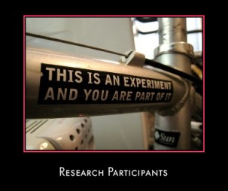

***Thinking & Writing Like a Social Scientist*** 

* *Pseudononphonoscientiaphobia*: the fear of not sounding scientific.
* You must write like a social scientist (this is a college-level paper)
* Use past tense, passive voice, and impersonal tone “It was found that…” not “my results”
* Use the term *researcher* for yourself, “the researcher found that…”
* Use the term *participants* to refer to the people in your study (participants = n).
* The term *data* is plural. *Datum* is singular.
* Three or more researchers are written as *et al* (example: *Brown et al*).
* Do not underestimate the amount of time required to complete the IA. Scientific writing is “way harder” than you think. Time management is the key
* Think about the best time to hold your experiment so that students will turn up.

Here are some transitional words/phrases to help with your writing:

*In addition, again , in fact, furthermore, another, indeed, certainly, besides, also, similarly, further, last, equally important, for example, in conclusion, lastly, for this reason, in the same way, first, along with, second, for one thing, finally, for another thing, next, of course, especially, to summarize, for this reason, to conclude, to begin with, in other words, for instance, in brief, specifically, to repeat, as an illustration, although, therefore, basically, however, in particular.*

* The entire report must be within 1800 to 2200 words.
* The format of your report: double-spaced, 1 inch margins on all sides.
* 12 pt font (serif font such as Times New Roman, Arial, Courier).
* Indent all new paragraphs (except for the Abstract).
* When dealing with numbers 0-9, write out as words (one-nine).
* If a sentence starts with a number, try to rephrase. Or start the sentence with the number fully spelled out (example: *Two groups were used to…)*
* Dates, time, ages, measurements are written as numbers.
* Within parentheses (&) use “&” but within the text write out “and.”
* Use APA (American Psychological Association) citation for your reference materials. See the Bibliography (List of Sources, Section H) near the back for more information.
* **Plagiarism** (copying someone’s words or work without giving credit) is an automatic zero (F) in IB and can cost you your certificate or diploma.

***Ethical Guidelines*** 

Your experiment must meet ethical standards.

* Any experimental study that creates anxiety, stress, pain or discomfort for participants is not permitted.
* You cannot include any studies that use animals in their research
* Any experimental study that involves unjustified deception, involuntary participation, or invasion of privacy must be avoided.
* All participants must be informed before commencing (beginning) the experimental study that they have the right to withdraw at any time. Pressure must not be placed on any individual to participate or to continue with the investigation.
* Each participant must be informed of the aims and objectives of the research, and must be shown the results of the research.
* All data collected must be kept confidential.
* Participants must be debriefed and given a chance to withdraw their data.
* All participants who are 16 years or older must sign an informed consent statement. For experiments with participants under the age of 16, parental consent must be obtained.
* A copy of the informed consent form must be included in the appendices (at the back).
* A copy of your briefing (beginning) and debriefing (end) statement must also be included in the appendices (at the back).

***What to Avoid***

There are certain things to avoid. Failure to do so may mean your internal assessment will score 0.

* Avoid conformity and obedience studies
* No animal research
* No placebo experiments
* No experiments involving ingestion (food, drink, smoking, drugs, inhaling, chewing)
* No experiments involving deprivation (sleep, food)
* No experiments involving young children
* No quasi-experiments--studies where the IV is naturally occurring such as gender (male-female), age (10 vs 18 yr olds), ethnicity (Haitian Americans vs Jamaican Americans), personal characteristics, culture, socio-economic status (rich or poor), handedness (left or right), native language (native French versus Mandarin speakers), educational level
* No correlational research that describes a relationship between variables
* No surveys or observational studies.
* Do not use something that is pre-packaged such as a computer program (or Internet site) or predesigned test. You must design all of your own materials.

***Sample Letter of Informed Consent***

A copy of the letter of informed consent should be included in the appendices. Make sure that the consent form is written in a way that informs the participants of the nature of the experiment.

Ethical issues to address include: the purpose of the research, expected duration (time it will last), procedures, right to decline, right to withdraw without consequences, factors to expect (risk, discomfort, adverse effects), research benefits, limitations of confidentiality, and how to contact you with any questions about the research. This process provides an opportunity for participants to ask questions and receive honest answers.

Researcher (your name): ________________________________________

Dear Participant,

As part of my IB Psychology Internal Assessment, I am carrying out a study on memory. This study is going to test your ability to memorize a list of words while listening to music. After the briefing I will ask you to check the boxes and sign the statement below.

  I have been informed about the nature of the experiment.

 I understand that I have the right to withdraw from the experiment at any time for any reason.

 I understand that all information or data about me will remain confidential. My anonymity will be protected as my name will not be identifiable.

 The experiment will be conducted so that I will not be demeaned in any way.

❑ I will be debriefed at the end and have the opportunity to find out the results.

  I give my informed consent to participating in this experiment.

Name and date __________________________________________________________

Contact number _________________________________________________________

Here is a sample consent form you may adapt for your own experiment:

***The Format of Your Internal Assessment***

Format of your report:

* Double-spaced, 10-12 pt font (simple, easy to read font), 1 inch margins on all sides.
* The report must be between 1800-2200 words.
* Title Page (word count goes here)

I. Introduction

A. Background of psychology concept

B. Theory/experiment to be replicated

1. Aim

2. Procedure

3. Results

C. Link to your replication

D. Aim of your experiment

E. Experimental hypothesis (IV and DV are clear)

F. Null Hypothesis

II. Exploration

A. Controlled variables

B. IV and DV explained

C. Research design explained and justified

D. Sampling technique explained

E. Participants characteristics explained

F. Materials explained

G. Procedure clear

III. Analysis:

A. Raw data is in appendix

B. Descriptive statistics (variance and central tendency) explained

C. Graph and table clear to hypothesis

D. Inferential stats explained

E. Link to hypothesis is present

IV. Evaluation:

A. Discussion of results in reference to the theory or study replicated

B. Strengths and limitations of the design, sample and procedure

C. Modifications are explicitly linked to the limitations

***Title Page***

The title page provides essential information about your IA. The following information should be centered on the page and should include:

The title

Your name

Your candidate number (Get these from Mrs. Mello)

The subject and level (Psychology SL)

Date of submission (final exam date)

Word count

The title should give a clear indication of the experimental method and the specific topic of the study. A title “an experiment on memory” is not specific enough. The title should include the hypothesis and exact variables being investigated.

Your hypothesis will determine how the title is constructed, for example, if the research hypothesis is “*the mean number of words correctly recalled by a group using the list with category headings will be greater than the number of words correctly recalled by a group not using category headings,” then the title would look like this:*

***Title:* An experiment to investigate the**

**effect of category headings on the recall of a list of words.**

The title must include:

* the method used (an experiment)
* the topic under investigation (recall)
* the variables (category headings and their impact on word recall.)

1. ***Introduction Approx. word count: 600***

* Indent every paragraph.
* Like a funnel, your first paragraph moves from general information to the specific study.
* Begin with a general introduction to the psychological subject area under investigation--the broad area of research

(ex: cognitive psychology).

* Include a definition if meaningful.
* Then introduce the general area to which your study was relevant (ex: memory)
* Then move to the specific study that you will be replicating. (ex: *Kahneman and Tversky*, 1979).
* For studies with more than 2 authors, use the phrase ***et al*** (which means “everyone else”).

**2nd Paragraph**:

* What did the original researcher find? Use exact data, numbers, statistics, details.
* By explaining the original experiment, you should state why you think the study is worth replicating. What value does this research have on our understanding of human behavior?
  + Include in the explanation of the theory – Aim, procedure, results

**3rd Paragraph:**

* Now clearly set out what you are going to investigate.
* Justify the **aim** of your study--a clear statement about what you're going to study.
  + *Aim: to investigate the effects of particular adjectives on the formation of impressions.*
  + *Aim: to investigate the effect of leading questions on estimation of speed in a car accident.*
* Provide the rationale (reason) for the investigation—and give clear justification for why this topic is important to study. How did your ideas develop from the previous research and why was this considered to be an interesting area of investigation?
* Give your reader a general idea of how you went about (or will go about) doing your study.
* Be sure to explain the **independent variable** (IV) which is what you are changing.
* The **dependent variable** (DV) is how you will test (measure) if there is an actual difference.

**Last Paragraph:**

* End with your specific research hypothesis. This means a clear prediction of what you expect to find through your investigation. By revealing related research studies, you can now make a scientific prediction for your study and explain the reason(s) behind your prediction. How did you choose your hypothesis? Clarify HOW and WHY your specific study tests your theory.
* The **research hypothesis** (H1) should be clearly justified by the previous research. It should be written in an operationalized form, which is precisely testable. The research hypothesis predicts how the IV is expected to affect the DV.
  + *H1:Participants will remember more words in the experimental group which received white noise.*
  + *H1: Participants in the loud noise condition (experimental group) will recall less of the words than people in the no-noise condition (control group).*
* The **null hypothesis** (H0) is the alternative hypothesis and should state that the results found are not due to the manipulation of variables but rather due to chance (time of day, participant variables, noise, etc). The null hypothesis states that there will be no effect from the manipulation of the independent variable (IV) on the dependent variable (DV).
  + *H0: The level of noise will have no significant effect on the number of words recalled.*
  + *HO: The introduction of scent to the experimental group will have no significant effect on the number of words recalled.*

***Hypothesis Examples:***

**Example #1:**

**H1:** *The number of words recalled in a memory task will be significantly greater when participants learn and recall words while exposed to the same smell than when participants are exposed to different smells during learning and recall.*

**H0:** *Presence of same or different smells during learning and recall will have no significant effect on the number of words recalled.*

**Example #2:**

**H1:** *Participants who hear background music while recalling a list of words will recall significantly more words than participants who hear white noise during recall.*

**H0:** *Presence of background music during recall will have no significant effect on the number of words recalled.*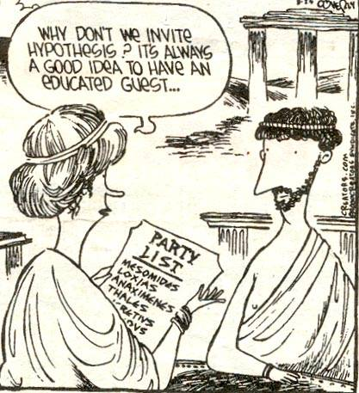

***How to Operationalize Your IV & DV***

Psychologists have more difficulty agreeing on operational definitions than physical scientists. The term **operationalize** means that you specifically define the variable so that there are no questions about what you mean. In order for an experiment to have validity, you must design a test that measures what you wanted to measure. Using a ruler to measure gallons is not the right tool. Using a petri dish to measure a desk is also not correct. 

Let’s look at some examples:

* **If I wanted to test the effects of loud rock music on concentration.**

*Rock music is my IV.* *But what do I mean by “rock”? I could mean classic rock, heavy metal, hip hop, old school, classic rock, Elvis…? And what is meant by “loud” or “soft” music?*

*“I’ll crank it up until it sounds loud to me” is not scientific. “I’ll set the volume on the stereo to 8” is better. “I’ll measure the sound with a sound meter and report the terms in decibels” is best. Your IV range (1-10 volume) should be large enough to show a real difference. How will I measure the DV “concentration”? Will I give a page of math problems? Several pages? How many do the participants have to complete to prove that they concentrated?*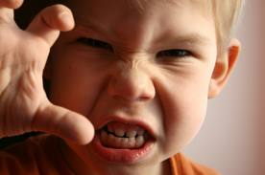

Here is another example:

* **Exposure to TV violence causes aggression in children.**

*TV violence is my IV…but how do you define violence? Could violence be different based on culture, age, or previous life experiences? We could define violence as “physical contact that causes harm to another person” or “an illegal act taken place” or “if hitting occurs 2 times or 10 times.” How much exposure are you talking about? 1 hour? 10 hours per week?*

*How old are the children? How do we define the DV--children’s aggression? We could make a 7-point scale that includes verbal abuse-kicking-hitting-screaming. We could tell a story and count the number of direct-attack responses the child gives. We could observe violent play (guns, knives, tanks) versus non-violent play (dolls, art, tools).*

**Do affectionate mothers have better marriages? (define affection, define better)**

**Do students learn better from popular professors? (define better, define popular)**

**Does student morale affect the amount of work output? (Define morale, define work output)**

***Sample Intro***

Cognitive psychology deals with mental processes such as memory. Research indicates that human memory is not just a replica of experience, but is in fact reconstructive. Memory is now largely studied from an information-processing approach, which focuses on encoding, storage, and retrieval. These three components are involved in the process of remembering. One of the most influential theories of information processing is schema theory based on the concept of schema, a concept first used by Bartlett (1932) as part of his theory of reconstructive memory.

Schema is a concept defined as an integrated mental network of knowledge, beliefs, and expectations concerning a particular topic or aspect of the world. It is believed to affect memory processes at many levels. Bartlett developed schema theory in his book *Remembering* (1932). His schema theory suggests that all new information interacts with the old information represented in the schema. What we remember is influenced by our existing knowledge and experience. Our knowledge is stored in memory as a set of schema-- simplified, generalized mental representations of everything we understand by a given type of object or event, based on our past experience. According to Bartlett, we reconstruct the past by trying to fit it into our existing schemas, and the more difficult this is to do, the more likely it is that elements are forgotten or distorted. On the basis of this, it can be expected that people will remember information that is consistent with their schema and forget schema- inconsistent information.

Schema theory provides us with ready-made expectations which help to interpret the flow of information reaching the census, and help to make the world more predictable. Furthermore, schemas allow us to “fill in the gaps” when our memories are incomplete. Although *Cohen* (1993) criticize the schema theory on the basis that the concept of schema was too vague to be useful, schema theory has proved useful in our understanding of cognitive processing involved in remembering. *Loftus and Palmer* (1974) experimental work with eyewitness testimony also demonstrated that human memory can be influenced by leading questions and “reconstructed memory” to fit the schema. This can be used to say that “memory may be influenced by schema processing.”

Researchers have discussed with schemas influence information processing. One such study is by *Anderson and Pitcher* (1978), who found that schemas have some effect at retrieval as well as at encoding. In the same line, *Brewer & Treyens* (1981) tested memory for objects in a room. Participants were brought into an office room with a number of consistent and some inconsistent objects and were told to wait. After 35 seconds waiting in the office, the participants were called into another room and given the unexpected task of writing down what they could recall from the office room. The results show that schema-consistent objects were more accurately recalled then schema-inconsistent ones. This indicated that memory for the scene was apparently strongly influenced by the pre-existing office schema, and when the participants had to recall details, they supplemented with default values from this schema. We have chosen to replicate *Brewer & Treyens* (1981) in our research because it is relevant to investigate if schema processing is actually as consistent as they found it to be.

Due to the suggestions of *Bartlett, and Brewer, and Treyens’* (1981) study, the aim of this experiment is to determine if schema processing effects memory for places such as an office room in the school like Norre Gymnasium. Our experiment will be carried out by presenting the participants with a list of mixed object normally present in office room (consistent) as well as objects not normally in an office room (inconsistent).

**HO Null Hypothesis**: there will be no difference in the recall of schema-consistent objects and schema- inconsistent objects.

**H1 Research Hypothesis**: the mean number of schema- consistent objects recalled will be higher than the mean recall of schema-inconsistent objects.

***B. Exploration Approx. word count 400-500***

* The method section is where you describe how your study was designed and carried out.
* In this section you demonstrate your understanding of the experiment as a quantitative (quantity) methodology.
* Anyone should be able to replicate your study EXACTLY by the thoroughness of your description.
* The section is subdivided into 3 sub-sections, each with a label:

**Design**

**Partipants PParticipants**

**Materials &**

**Procedure**

* ***Method: Design***
* Identify the design you have used – either **independent samples** or **repeated measures** (see next page for these).
* Explain and justify why you chose the design you did (to avoid order effects, etc). Why is it the best way to conduct your study? What are the strengths and limitations of this design?
* Describe the controls you have undertaken to avoid extraneous variables or **confounding variables** (ex: have a standard script and give the same standardized briefing).
* The two groups in your experiment should be treated exactly the same--except for the IV.
* All instructions to the groups should be scripted to ensure they are identical.
* All other conditions should be identical as far as possible.
* Note any inadvertent differences in treatment and discuss in your report.
* Again, identify the independent (IV) and dependent (DV) variables (operationalized).
* Document how ethical guidelines were followed. Explain how consent was obtained and how the briefing and debriefing were carried out. Remind participants that they are free to leave the experiment at any time.
* **Debriefing**: At the end, thank all participants and inform them of their right to know the results of your experiment. This should be a script (in your appendix).

**Independent Samples Design: (n=20)**

**2 different groups of participants. One group was given the experimental treatment, and the other group received no treatment. If you choose the independence samples design, then you need 20 participants; 10 in each group.**

***Ex*: *one group was given a list of words to memorize while listening to very loud music. The other group is simply given a list of words.***

**The group in which the IV is manipulated (the music is played) is the experimental group.**

**The group that gets no treatment is the control group. This group allows you to see memory under normal circumstances.**

**Strengths:**

**\* Participants are less likely to guess the hypothesis of the study.**

**\*Participants are less likely to be bored or tired with the test.**

**\*The same materials may be used with both groups.**

**\*Participants don’t get tired.**

**\* You avoid bringing back participants 2x.**

**\*Used when it is not possible to use the same participant in 2 experimental conditions.**

**\*Participants won’t be able to improve their skills simply by repetition (order effects).**

**Limitations:**

**\*Takes longer to find new participants, discuss, debrief, consent.**

**\*There may be participant variability--may differ so much (ex: in memory ability) that the differences between the two groups may actually be due to this and not the manipulation of the IV. This difference could bias the behavior being measured (if randomly assigned).**

**Repeated Measures Design: (n=10)**

**This design involves using the same participants in both the experimental and the control group. If you choose the repeated measures design you need 10 participants.**

**For example: *the group is asked to memorize and recall a list of words (the control group). Then the same group is asked to memorize and recall a similar list of words while listening to rock music (experimental group).***

**Strengths:**

**It eliminates the problems of participant variability (same people 2x)**

**It requires fewer participants (10 participants)**

**Faster for paperwork, informed consent, debriefing, etc.**

**Preferred for statistics because it shows a large difference.**

**Limitations:**

**Doing the same task twice may result in order effects (practice).**

**May be hard for studies about learning, memory, attitude formation, exposure can change behavior: “forget the last list…look at this one”, “change your attitude”**

**Tired, fatigue of participants**

**Another potential problem is demand characteristics, where participants guess the aim of the study and don’t act naturally because they want to be helpful (or the opposite).**

**This design does not work for all types of experiments. It is best for experiments where the researcher wants to see how an IV may change participant’s performance on a specific task.**

***Confounding Variables***: 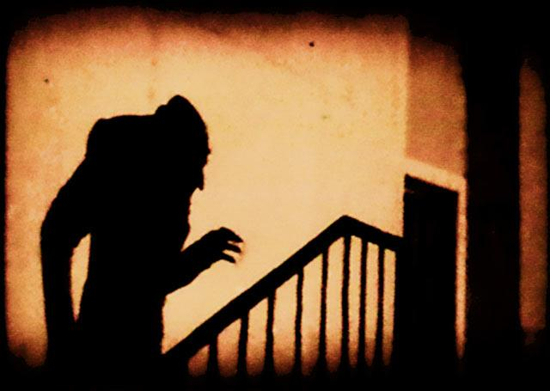

These are hidden (lurking) factors that could skew your results and cause low internal validity in your test. Researchers must try to eliminate all confounding variables possible.

These variables could include:

* Bias (either from the researcher or the participant) for example is your sample bored or concentrating? Personal experience can bias both sides.
* Selection process: self-selected volunteers may be over-eager, and try to appear likeable, “normal,” and responsible. Participants who did not want to be selected may be uncooperative, defiant, or defensive.
* The type of participant selected (Hell’s Grannies, inmates, Amish teens). Maturation: how mature are your participants?
* The participant has practiced what you are asking (order effects). Maybe a friend told him/her what to expect and they are ready.
* Participant interactions with each other or with you (threatened, flirtatious, rapport).
* **Hawthorne Effect** (Demand Characteristics): trying to please or guess results. If you are too secretive they try to solve the puzzle; search for clues. They may read into non- verbal clues, the way you stand, your reaction to answers, or how you read a script.
* Teacher in a classroom environment may be distracting. Same in office environments.
* Participant health: colds, allergies, headache, etc.
* Equipment malfunction.
* Environment: lights, noise, distractions.
* Natural occurring events: weather, time of day.
* Other Distractions: participants did not eat, clothes are uncomfortable, lack of sleep, school team did/not win, pep rally day, etc.

We counter-balance these confounding variables by:

* Having everything scripted so you sound the same to every participant. You can even audio or video tape your instructions (though this can feel too artificial).
* Use a single-blind (participants do not know if they are in the control or experimental group) or double-blind (you as the researcher also don’t know).
* Decide if you need to collect information individually or as a group.
* Try to consider the same time of day for your experiment.
* Be aware of non-verbal clues. Stay focused on your participant (no texting or yawning).
* Admit in your discussion section that a potential confounding variable may have occurred. Don’t worry about *Imperfectaphobia* (the fear of not being perfect).

***Standardized Briefing & Debriefing Notes***

You should write a script to use in the briefing of your participants. This script should include the aim and instructions regarding the procedure of the study, as well as information about ethical issues (see the consent form).

Attach a copy of your standardized briefing notes in the appendix (at the back). By using one standardized briefing, you ensure that you control all extraneous variables that could interfere with the experiment.

Debriefing occurs after you have conducted the experiment. Standardized debriefing notes are a copy of the script that you used to debrief your participants once the experimental procedure is over.

The debriefing should include:

* Thank you for participating.
* The aim or purpose of the study.
* What you expect to find in your study.
* The results will remain confidential.
* Participants can learn about the conclusions drawn from the research when you have completed your analysis of the data.
* Remind participants that they have the right to withdraw their data, keeping with ethical standards.
* You may want to ask a question that helps uncover any limitations to your study, “were you aware of…”
* Attach a copy of the standardized debriefing notes in the appendix (at the back).
* ***Method: Participants***

The participants section describes the sample and how it was obtained.

* A sample of 15-20 participants is sufficient. Larger samples are strongly discouraged.
* Sampling procedures should be identified and justified.
* The sampling method (random, opportunity, etc.) must be identified (see next page)
* You must explain why the sampling method was chosen
* Explain how the participants were allocated to the experimental or control group. State the number of participants in each group.
* Identify the **target population**-- the group you are interested in and the one from which you draw your sample. It is also the one to which you will be able to generalize your results. This means that if your target population is “IB students who were non-native English-speaking students” you will be able to generalize the results only to “IB students who were non-native English-speaking.”
* How many people are in your target population? “*There are 1200 in the target population*.”
* Relevant characteristics of the sample should be identified (*ex: color blindness, English proficiency, musical ability).* Give an example of the group similarities (11th graders). What are the ages, grade-level, subject area and level, gender, and any other important details.
* Describe the sample in terms of the number of participants, age, and gender distribution. State the age range and mean. *(example: the 20 participants were evenly distributed between males and females. The mean age was 16. Because of the nature of the experiment, it was important that participants were not colorblind and that they were fluent in English).*
* Treat your participants fairly—be prompt, pay attention, be prepared, be polite, be professional, keep info private
* Before beginning the experiment, you may decide to eliminate participants who fail to meet your minimum requirements (English-language, not color-blind, low reading ability, etc).

**Types of Sampling Methods**:

Since you cannot sample the entire population, you select a **representative sample** from your **target population** *(example: to study teenage drinking habits, you would study 20 teens).*

* **Opportunity/Convenience Sampling**: whoever happens to be there and agrees to participate. This can be biased based on your location and may make it difficult to generalize findings.
* **Self-Selected Sampling:** volunteers are easy to find and highly motivated, but they may not reflect the general population, and they may display **demand characteristics**.
* **Purposive Sampling**: targets a group (all teens) based on the aim of the study. This group could still have diversity (race, age, gender) but could lead to bias (all teens are…).
* **Cluster Sampling**: random selection of just one part of the target population (ex: just call one state for a Federal election).
* **Snowball Sampling**: word-of-mouth recruiting of friends, neighbors, and family. This method helps to reveal hidden populations (homeless)-- but can bias or skew results (friends will only ask other similar friends). Also confidentiality and anonymity are not possible.
* **Random Sampling**: Every member of the target population has an equal chance of selection (like jury duty). It is assumed that if the group is large enough, then you will have diversity in your participants. (ex: names in a hat, sticks, cards, computer selected, etc.)
* **Stratified/Quota Sample**: draw random participants from sub-groups to reflect the actual population (ex: Asian students, Indian students, Af-Am students, Caucasian students).

It is also important to consider **participant variability**. If everyone were exactly alike, you’d only have to conduct your experiment 1x. If you are using 2 different groups (independent samples) then be sure one group isn’t great at math while one group suffers from math anxiety. Both groups should share some similar characteristics, or else there may be a sampling bias in your results. You can use random assignment to groups (flip a coin, assign numbers) or use matched group design.

**Matched group design** is more time consuming but is often used to eliminate participant variability between 2 groups. With time and planning you could match the 2 groups. This requires that you know the participants ahead of time.

**Control Group Experimental Group**

* track runner (17) 1 track runner (17)
* strong math student (18) strong math student (18)
* IB male (17) IB male (17)
* Spanish-speaking female (16) Spanish-speaking female (16)
* **Method: Materials**

This section is a list of materials developed for use in the experiment. Basic materials such as tables, chairs, paper, and pencil should not be listed. This may be a bullet list of items.

* Any written materials like a list of words to recall that were specially developed for this experiment should be listed. A sample copy should be in the appendix.
* Standardized briefing and debriefing notes and informed consent letters should be included in an appendix.
* Stopwatch and other items used in your experiment should be listed here.
* Describe what is used, not how it is used.
* Be sure you plan ahead for any special equipment you will need (video recorder, music system, DVD player and TV, stopwatch, etc.)
* Be sure you have copies of whatever forms, scripts, or documents you will need
* **Method: Procedure**

*Write this section in past tense.*

You must carefully and accurately describe how the experiment was carried out step-by-step. Enough detail should be provided so that another researcher could replicate the experiment. Procedures may be written either as a paragraph or in bullet point format.

* You must include reference to any ethical issues that were addressed--for example when briefing and debriefing were carried out (see next page).
* If you are writing in bullet points, make sure that enough details are included for someone to replicate your procedure (I might make them do that!)
* Write in chronological order. Be clear and concise.
* State whether you ran your experiments in groups, pairs, or individually.

***Ethical Guidelines***

Ask yourself….have I considered all ethical concerns?

* I have not caused any stress, anxiety, pain, or discomfort.
* I have asked everyone to sign an “informed consent” BEFORE beginning my experiment.
* I provided an adequate description to my participants of what they would be expected to do and what I was testing for.
* I used only mild (or no) deception, and I cleared up any misinformation or mild deception during the debriefing (after the experiment).
* I am careful with all data so that confidential information does not get lost, left, stolen, or discovered (laptop, lists, thumbdrives, signed forms, etc).
* I keep my own thoughts and lips sealed around others (and online) for confidentiality.
* I have tried to avoid all confounding variables from interfering with my research—including demand characteristics. I believe that any variables at this point are out of my control and are unlikely to alter or affect my results.
* I read a statement that debriefed all participants equally and thoroughly after my experiment was over. I gave participants a chance to ask questions, and a way to contact me with further questions or concerns.



***Analysis (6 marks)***

There are 2 different sections for the results. First you must conduct your actual experiment and collect all of the data. Your raw data will go in the appendix (at the back). Your finished data and explanations will go into two sections. You must create a table showing the mean or median or mode of your results – include either the range or the standard deviation – give your table a title

**Section E** is **Descriptive Data**: this means data that describes the sample population used (size, subgroups, demographics, age, gender).

**Section F** is **Inferential Data**: this means you can infer from the small sample something about the larger population.

***Results: Descriptive(written)***

The results should be stated in two ways: “say it” and “show it”

* A narrative (written) form--a written statement *(example: “the mean number of words recalled by the experimental group (X1) was 2.5 (X1=2.5).”*
* A graphic form that enhances the reader’s understanding and supports the text. These are graphs that the reader should be able to understand just by looking at the graph or the table. Tables could include mean scores or frequency of behavior.
* Be sure every part of your graphs are carefully labeled. There are many computer programs that will make these graphs for you (like MS Excel or PowerPoint).
* The data should be reported in a way that reflects the aim of the research hypothesis (*ex: you were trying to prove condition x over y, so make sure your graph shows x over y).*
* Raw data should not be included here, but must be in the appendix. Only summarized data should appear in the results section.
* A lower-case n refers to the number of participants (n=20)

The data collected in research can represent different levels of detail (referred to as the level of measurement of the data). There are 4 levels of measurement you can use:

**Nominal**

**Ordinal**

**Interval**

**Ratio**

**Nominal data**: *example: smokers and non-smokers; cat people versus dog people.*

* Simplest data to collect.
* As you record data, put it into categories (yes/no) and you simply count how many fall into each category.
* Nominal level provides the least amount of information of all.
* Only the **mode** can be used as a means of central tendency.
* Nominal data have fewer descriptive statistics that may be calculated.
* It is not recommended to carry out research that only produces nominal data.

**Ordinal data**: *example: track runners are ranked as number 1, 2 or 3.*

* Put into rank, or order from smallest to biggest, or first to last.
* We cannot say anything about how much better # 1 did compared with # 2 and 3--only who came in 2nd and 3rd.
* The difference between each score may not be equal.
* An example could be a Likert scales (strongly agree, agree, disagree, strongly disagree).

**Interval data**: *Peter is 179 cm tall, Pierre is 180 cm. Pierre is the tallest; Peter is the smallest*

* Other examples: *temperature (1-100); IQ scores (100); #s recalled on a memory test*
* Data is measured on a scale which has precise and equal intervals.
* Data at the interval level carries much more information than ordinal data.
* The mean, median, and mode may be calculated for interval data.
* If you rank interval data they become ordinal data.

**Ratio data**: *example: weight in grams is a ratio scale; 20 miles are 2x as far as 10 miles.*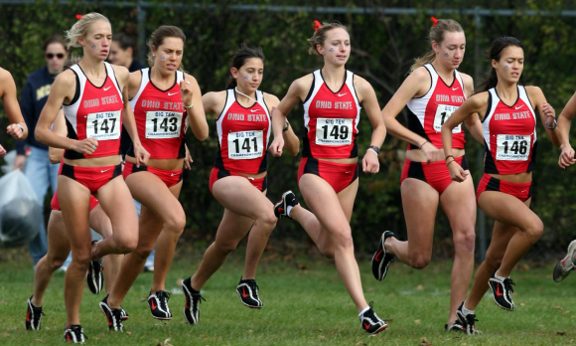

* Ratio data have the characteristics of interval data, plus they have a true zero point *(you can’t have a negative mile, or a negative weight).*
* There is an equal distance (intervals) between each data point.
* Ratio measurements lend themselves to more effective statistical analysis.
* Nearly all measures of both central tendency and dispersion can be calculated.

**Measures of Central Tendency**

The measure of central tendency tells you something useful about a distribution—but it only describes one aspect. You should calculate *both the central tendency and dispersion* (if the level of measurement of your data allows it). This depends on your data and whether you chose the **mean, median**, or **mode**.

**Mean**:

The sum of the values divided by the number of values.

Not influenced by outliers, or extreme scores.

Very imprecise statistic, not very useful if there are many modes.

*Example: 2+4+6+8+7= 27 27 divided by 5= 5.4*

*The mean number of words recalled by the experimental group (X1) was 2.5; X1=(2.5)*

**Median**:

List numbers from lowest to highest and pick the middle one.

Not distorted by outliers, good to use if data is skewed.

Can be distorted by small samples.

The most sensitive measure of central tendency.

*Example: 2, 4, 6, 7, 8 Median= 6*

**Mode:**

Value that occurs most frequently in a sequence.

Mode can be used for nominal data.

Mode is not distorted by outliers but may be distorted by small samples.

1, 3, 6, 6, 6, 6, 7, 7, 12, 12, 17 = 6 (unimodal)

1, 1, 2, 4, 4 = 1 & 4 (bimodal)

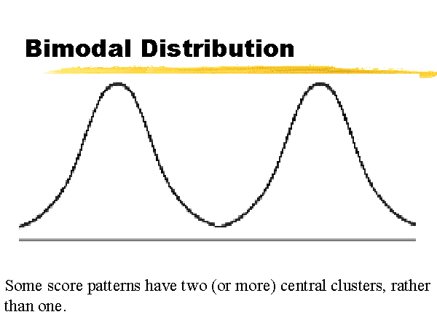

**Measures of Dispersion**

In statistics, dispersion (also called variation) shows how your data is distributed (or spread out). Common measures are range and standard deviation.

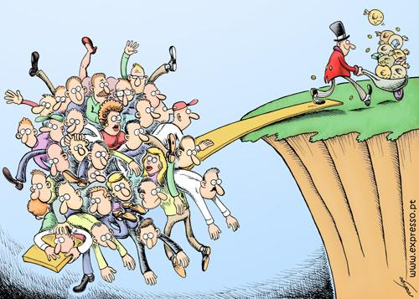

**Range**:

Easy to calculate, subtract the smallest from the largest number to determine the range. This number provides an indication of statistical dispersion.

Range is the most distorted by outliers, (as in salary, age).

It is a poor and weak measure except for larger populations.

*Example for the set: 3,5,6,7,9,3,10*

*10 (highest) – 3 (lowest) = 7 The range is 7*

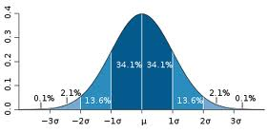

**Standard Deviation (SD)**:

The most sensitive measure of dispersion using all data (symbol **σ**).

Shows how much variation or dispersion from the mean (average, or expected).

Effects that fall far outside the range of SD are considered statistically significant.

*Example: IQ scores (100 is average IQ; 1 SD, 2 SD, -1SD, -2SD)*

*Average Grade is C; B is one above, D is one below*

**To calculate the SD:**

1. Find the **mean** of the distribution.
2. Subtract each score from the mean.
3. Square each result (deviation).
4. Add the squared deviations together.
5. Divide by the total number of scores (n-1) you subtract 1 to get rid of any outliers.
6. This result is called the variance.
7. Find the square root of the variance. This is the SD.
8. Now you can compare the mean to the SD.

*Ex: compare 3 class scores out of 100: 78, 80, 92; 2/3 of your scores are 1 SD from the mean.*

**Skewed Data**

Once you have drawn your range or standard deviation, you may notice that your data is skewed right or left (positive or negative). A normal range of distribution is double-tailed (2 tailed) as in the example of a SD on the previous page. A skew usually indicates that the data is single-tailed (left or right).

Your wording of your hypothesis may also determine your tail (*example: changing temperature in the room will increase the time needed to complete the math test).*

* A **negative** skew means that the tail is on the left side. The bulk of responses are to the right of the mean.
* A **positive** skew means that the tail is on the right side. The bulk of responses are to the left of the mean.

This is usually because of outliers in your data:

* 1 participant is much older than the average.
* 1 participant is much better (or worse) at the task (DV).
* 1 participant has an extremely high (or low) IQ.

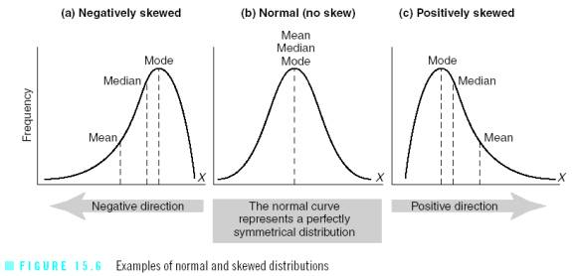

**Level of Measurement:**

Nominal Data

**Central Tendency:**

Percentages; mode

**Possible Tables/Charts:**

Frequency table, pie chart, bar chart

**Dispersion:**

none

**Level of Measurement:**

Ordinal Data

**Central Tendency:**

Percentages; mode, median

**Possible Tables/Charts:**

Frequency table, frequency polygon, bar chart

**Dispersion:**

Range

**Level of Measurement:**

Interval & Ratio Data

**Descriptive Statistics:**

Mean, median, mode,

**Possible Tables/Charts:**

Frequency table; box and whisker plot; bar chart; histogram

**Dispersion:**

Quartiles, range, standard deviation

This also affects what type of graphs and tables you can use and influences your choices of statistical tests. Tables and graphs may be drawn using the computer. No matter what graph you choose, it must accurately reflect the data in relation to the prediction of the research hypothesis. One graph is sufficient. Do not produce irrelevant graphs (that have nothing to do with your research). The report should not include graphs showing each individual participant’s score. Label each part of the graph.

* **Vertical (y-axis, DV)**
* **Horizontal (x-axis, IV)**

**Bar-graphs** are good to compare categories. **Histograms** are good for a continuous IV.

***Results: Inferential Statistics***

Even if you suffer from *calculatophobia (*fear of statistics)*,* you must include inferential statistical analysis of your results in this section.

You probably have some idea of the results that you wanted from your experiment. Do not try to be a cheerleader rooting for your specific results. In research, you want to be a non-partisan (not taking sides) bystander. Don’t be so in love with your outcome that you lose your professional objectivity and become biased in your evaluation of the data. You must interpret the data regardless of the outcome—even if you failed to show a significant change between rock music and classical music (for example).

Inferential statistics ask if your random sample really represents the whole population. Can we infer from the small group how the large group would behave?

* Example: *Could I ask 10% of the class to place a vote on something, and then apply that vote to the entire class?*
* *Could 1 handful of beans tell me the health and taste of the entire bin of beans?*
* *If 10 states voted for one presidential candidate, could we infer that the rest of the country will likely vote the same way?*
* *Is it likely that the math anxiety experienced by economics majors could be applied to the entire population of people majoring in economics that could have been sampled?*

**The Null Hypothesis** (N0)

The Null Hypothesis (N0) assumes that there is no significant difference in your data.In statistics, The Null is assumed to be true…your experiment is either proving the Null to be right or wrong. *Think of this like a court of law where you are assumed innocent until proven guilty.*

So, if the starting assumption is the **NULL hypothesis** (N0), than this means the results of your experiment were caused by probability or chance (like flipping a coin). This also means that your IV (Independent Variable) did not really have an effect. To test this theory, we need to conduct an inferential statistics test.

For example: *I flip a coin 20 times while listening to heavy metal rock music. My results are 11 heads and 9 tails. A statistical test would show no real effect from the rock music. The results were probably just chance.*

The further apart your observed results are from your expected results, the more likely it is that your IV (rock music) really did make a difference *(example: if my results were 3 tails to 17 heads).*

***Do I Accept or Reject the Null Hypothesis?***

The goal of research is to either accept or reject the null hypothesis. We want to establish that there actually is a relationship between the IV and DV and that any results we have obtained were not just due to chance.

Again, working off of your null hypothesis, if the null is true…then there is no significant difference caused by your Independent Variable (IV). *This means you could have played rock music, classical music, or no music and the results would have been the same*.

* This statistics test will establish that the results are not due to chance.
* This means that the data are significant (95% or higher, or p<0.05).
* When the data are significant (95% or higher, or p<0.05) we ”reject the null hypothesis.” This simply means that the IV did cause significant changes in the DV.
* When our hypothesis is not proven to be statistically significant, we must ”accept the null hypothesis.” (You can score just as high in the IA process even if you have to accept the null. The fact that you understand why and how is what is important).

After analyzing your data with inferential statistics, you need to make a decision on the significance of your findings. Were your results due to a real difference between the groups, or were they the result of chance or error?

Here are some examples of how to properly state the null:

* *“The results were found to be significant (p<0.05), which means that the probability of the results occurring by chance if the null hypothesis were true is less than 5%. Therefore the null hypothesis was rejected and the research hypothesis was accepted. There does appear to be a real difference in the number of words recalled by males and females.”*
* *“A chi-squared (X2) test was carried out because the data were nominal and two independent samples were being compared. A significant difference was found (X2=4.78, p<0.05) and we can therefore reject the null hypothesis.”*
* *“There was a significant difference between the number of letters recalled by the experimental group and the control group. (X2=4.2, (degree of freedom) d.f.=1, p<0.05)”*

***Finding the Best Statistical Test***

There are 3 statistical tests that are generally used for the IA – you only use ONE:

* **Chi-Squared Test**
* **Mann-Whitney U Test**
* **Wilcoxon Signed-Ranks Test**

You should refer to the design of your experiment and the level of measurement of your data to justify your choice. You will need to explain why you chose the test that you did. The charts below should help you make a solid decision in selecting the right test for the job.

* **Parametric**: if the data is **ratio** or **interval**, evenly distributed (homogenous, bell curve), often best with a large sample. A T-Test is an example (not a recommended choice).
* **Nonparametric**: if the data is **ordinal** or **nominal**, this test gets rid of outliers if your data is skewed (important because of our small sample size).

Next, figure out if you need a **paired** or **unpaired** test (also based on the **design method** used).

* **Paired**: when you use the same people (**repeated measures**), the values are matched *(before & after with the same group).*
* **Unpaired**: when you use 2 groups of people (**independent sample**), when the values are not matched (*control & experimental group, smokers & non-smokers*).

**Level of Measurement:**

Nominal Data

**Test for Independent Samples Design**:

Chi-squared (X2)test

**Test for Repeated Measures Design**:

None

**Level of Measurement:**

Ordinal, Interval, Data

**Test for Independent Samples Design**:

Mann-Whitney U test

**Test for Repeated Measures Design**:

Wilcoxon Signed Ranks Test

**Chi-Squared Test**: used for nominal data in an independent samples design in an experiment testing the difference between two conditions (or categories).

* Examples: *dog people or cat people; smokers & non-smokers; wear glasses & don’t wear glasses; Republicans & Democrats; male & female.*

**Mann Whitney U Test:** used for ordinal data (or higher data) in an independent samples design in an experiment testing the difference between two conditions.

* Examples: *The control group solved a puzzle with no noise, the experimental group solved the puzzle with loud music playing.*
* *The control group performed a task alone, the experimental group performed a task in front of others (social facilitation).*
* *The control group memorized a word list. The experimental group smelled vanilla while memorizing a word list.*

**Wilcoxon Signed Ranks Test**: used for at least ordinal data (or higher data) in a repeated measures design in an experiment testing the difference between two conditions.

* Examples: *Before and after; same group of 10 participants.*
* *A group of 10 first tried to learn new words; then the same group tried to learn new words with pictures next to them.*
* *A group of 10 first tried to solve a puzzle with no noise; then the same group tried to solve a puzzle with white noise playing in their ears.*

For video explanations of these tests, visit: [www.statisticslectures.com](http://www.statisticslectures.com)

You can double check your calculations at: [www.graphpad.com/quickcalcs/index.cfm](http://www.graphpad.com/quickcalcs/index.cfm)

**The Chi-Squared (X2) Test**

When you are interested in the relationship between 2 categories, you can use a chi-squared test.

*Example: Students created flyers on different kinds of color paper—white paper, pink paper, and yellow paper. They watch the table to see if participants would take a white flyer, a pink flyer, or a yellow flyer.*

***STEP 1: Draw a chart with boxes.***

Take

Flyer

Don’t

Take

Flyer

White Paper

Pink Paper

DV

Independent Variable

Yellow Paper

***STEP 2: Fill in the boxes with the results that you observed (O=observed results).***

***STEP 3: Add up the observed numbers to be sure your math is correct (columns and rows).***

Take

Flyer

Don’t

Take

Flyer

White Paper

Pink Paper

DV

Independent Variable

O: 32

O: 8

O: 22

O: 38

Yellow Paper

O: 30

O: 20

90

+ 60=

+ 50 =

+ 60

40

**150** total # part.

O=Observed

***STEP 4: Find the expected results (E) for each cell. Take the column total X the row total then divide by the total number of participants.* Columns go up and down; rows go across.**

***Example: 90 x 40 / 150 = 24***

Take

Flyer

Don’t

Take

Flyer

White Paper

Pink Paper

DV

Independent Variable

O: 32

E:

O: 8

E:

O: 22

E:

O: 38

E:

Yellow Paper

O: 30

E:

O: 20

E:

90

60

50

60

40

**150 (Total)**

O=Observed

E=Expected

* **O: Observed**: the data that actually happened.
* **E: Expected**: The expected amount that there should be (based on percentages).
* The further apart the observed is from the expected, the more likely that there **is** a significant difference.

Take

Flyer

Don’t

Take

Flyer

White Paper

Pink Paper

DV

Independent Variable

O: 32

E: 24

O: 8

E: 16

O: 22

E: 24

O: 38

E: 36

Yellow Paper

O: 30

E: 20

O: 20

E: 30

90

60

50

60

40

150

***STEP 5: Double check that the expected values also add up to the column and row total.***

***STEP 6: (Almost Done!) Now you have to plug each cell into the formula.***

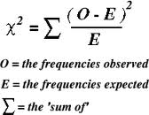

* Cell 1: (O-E)2 divided by E = (32-24)2/24= (8)2/24 = 64/24 = 2.6
* Cell 2: (O-E)2 divided by E = (38-36)2/36 = (2)2/36 = 4/36 = 0.11
* Cell 3: (O-E)2 divided by E = (20-30)2/30 = (-10)2/30 = 100/30 = 3.33
* Cell 4: (O-E)2 divided by E = (8-16)2/16 = (-8)2/16 = 64/16 = 4
* Cell 5: (O-E)2 divided by E = (22-24)2/24 = (-2)2/24 = 4/24 = 0.166
* Cell 6: (O-E)2 divided by E = (30-20)2/20 = (10)2/20 = 100/20 = 5

***STEP 7: Add the total number of cells. Total:*** 15.206

***STEP 8: Now you check a Chi-Squared Chart/Table to see if your results show significance.***

* For Chi-Squared tests, there is a number called the “degrees of freedom” (df) which has to do with how many columns and rows you used. To calculate the df you use the following formula: the # of rows in your table-1; multiply that by the number of columns -1= df.

Here is the easy version:

1 df (4 cells) your answer must be greater than (>) 3.84 in order to be significant (p<0.05). Anything less than (<) 3.84 means you must accept the NULL.

2 df (6 cells) must be greater than (>) 5.99. Anything less means you must accept the NULL.

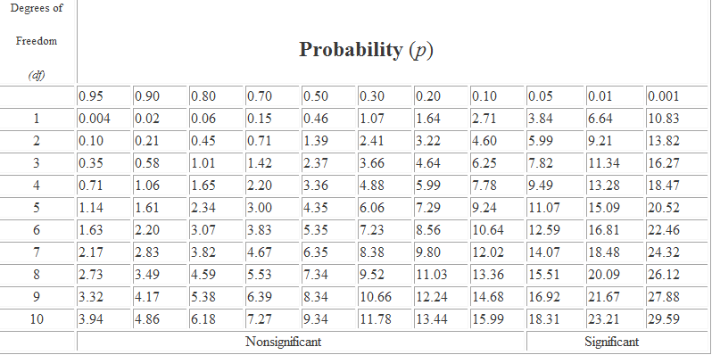

Chi-Square Chart

**Mann-Whitney U**

(also called the Mann–Whitney–Wilcoxon (MWW) or Wilcoxon rank-sum test)

***STEP 1: Rank all of your scores in order from lowest (Rank 1) to highest (Rank 15). Do this together for both groups—Control Group and Experimental Group.***

***\*****My example only goes to 15, but if you used 20 participants, then Rank all the way to 20.*

*Rank: 1, 2, 3, 4, 5, 6, 7, 8, 9. . .20*

***STEP 2: Add the sum of each group.***

**Experimental Group Control Group**

*Time (min) Rank Time (min) Rank*

*140 4 130 1*

*147 6 135 2*

*153 8 138 3*

*160 10 144 5*

*165 11 148 7*

*170 13 155 9*

*171 14 168 12*

*193 15*

*________________________________________________*

***(N1=8; R1=81)*** ***(N2=7; R2=39)***

***N=*** *Number of participants in each group*

***R=*** *the total when we add all of the ranks together*

***STEP 3: Now use the following formula to find U (U= Hypothetical Data).***

R=Rank; N=Total Number of Observations

**U=N1*N2+ N1(N1+1)-R1**

*Example:* U = (8) x (7) + 8*(9) - 81

U= 56 + (8 x 9) - 81

U = 56 + 72 – 81

U= 128 – 81 = 47

U = 47

***STEP 4: Go to the Mann-Whitney Chart/Table (on the next page).***

* U = 47.
* Is 47 between the N1 to N2 range of numbers on the chart?
* If YES, then reject the NULL Hypothesis.
* If NO, then accept the NULL Hypothesis.
* 47 is **NOT** between the N1 to N2 range of numbers on the chart so we must accept the Null hypothesis.
* This means that our independent variable (IV) did not make a significant difference in the results (Dependent Variable, DV).

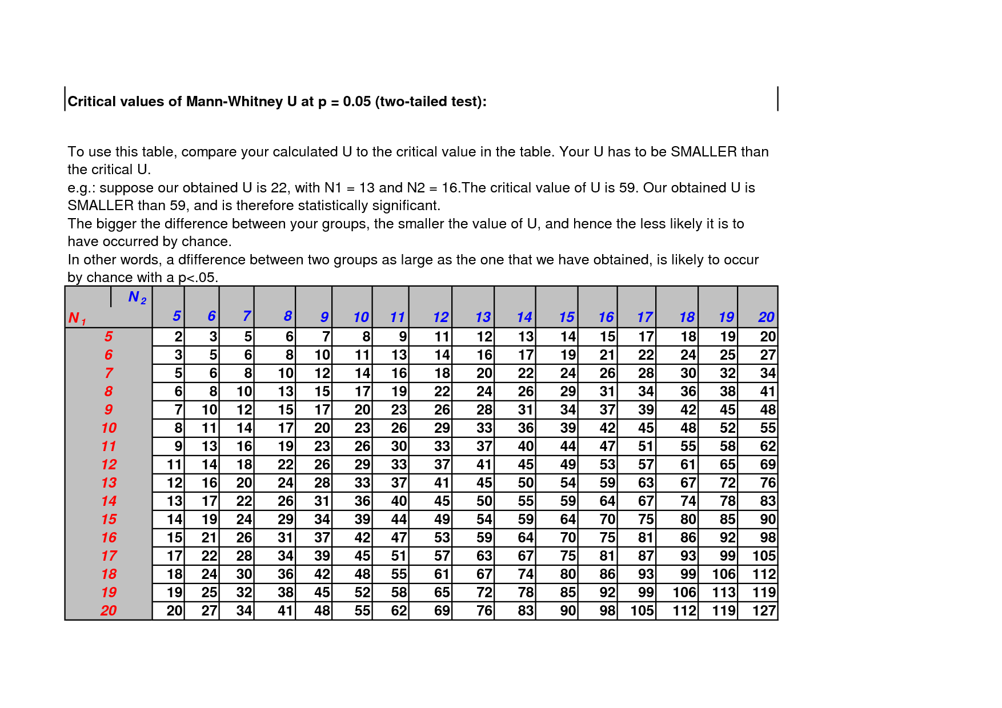

**Wilcoxon Signed-Ranks Test**

* This test is used for the repeated measures design to see if there is a significant difference between the before and after trials of your experiment.
* The significance for this test must also be 0.05 (called the Alpha Level for this test).
* This test involves finding the “critical Z-score” from a Z-table which is **1.96**.
* If your Z-score is **less than -1.96 or greater than 1.96** then **reject the null** and accept your alternate hypothesis (H1).
* This will mean that your Independent Variable (IV) did make a significant difference.

***Step 1: Make a chart showing the scores before and after.***

**Before After**

28 12

17 31

36 19

35 14

32 20

33 19

***Step 2: Add a 3rd column showing the difference between the before and after scores. You find this difference by subtracting.***

**Before After Difference**

28 -(minus) 12 16

17 31 -14

36 19 17

35 14 21

32 20 12

33 19 14

***Step 3: From now on, only this “Difference” column matters. Rank the “Difference” scores.***

* The highest number ranks #6 (there are only 6 numbers in this sample. If there were 10 or 20 then your highest rank would go to 10 or 20).
* The lowest number ranks #1.
* Our ranks for this sample would be:

16 Rank # 4

-14 # 1

17 # 5

21 # 6

12 # 2

14 # 3

***Step 4: add up your positive ranks (not the scores, but the rank #s). R=Rank***

∑ R+ = 4 + 5 + 6 + 2 + 3 = 20

***Step 5: add up your negative ranks (not the scores, but the rank #s). R=Rank***

∑ R- = 1

***Step 6: T= the smallest of these numbers***

T= 1

***Step 7: Solve the following equation to find the z score.***

T = 1 N (n) = 6 (we had 6 participants in this data set)

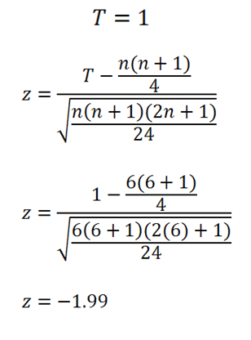

If Z is less than -1.96, or greater than 1.96, you have to reject the Null Hypothesis.

**Z = -1.99** (Reject the Null). The IV did make a difference.

***T-Test***

Not a recommended test to use because our sample size is so small (and it’s considered a parametric test). If you decide to use the t-test be sure to justify its use (for example: saying that although the criteria for parametric tests are not met these tests are very robust). Use this test only if no other statistical test will work.

* *Example: Use when you have 1 variable in 2 situations. You want to find the mean (average) between 2 conditions.*

***STEP 1: Find the mean from your data set.***

* Data: 4, 2, 3, 4, 1, 3, 4 = the sum of these is 21 there are 7 scores (N=7)
* Mean = total (21) divided by 7 = 3
* Mean = 3

***STEP 2:*** ***Subtract the mean from each score.***

* 4-3= 1 2-3=-1 3-3=0 4-3=1 1-3=-2
* 3-3=0 4-3=1

***STEP 3: Rank the items in order (largest to smallest).***

* 1, 1, 1, 1, 0, 0, -1, -2

***STEP 4: Add the sum of the Positive Ranks.***

* 1 + 1 + 1 + 1 = 4

***STEP 5: Add the sum of your Negative Ranks.***

* -1 + -2 = -3

***STEP 6: Take the smallest score (t) from Steps 4 & 5.***

* t=-3

***STEP 7: If t>1.96 or <-1.96 then p<.05 (significant or valid).*** This means that the independent variable (IV) did cause the change in the Dependent Variable (DV).

* -3 is less than <1.96 so the test is NOT valid. You must accept the NULL.
* The results are caused by chance, not the IV.

***Evaluation Approx. 600 words***

The discussion is the final part of the paper. This is an important part of your report, so make sure that you do everything that is set out in the assessment criteria. In this section you:

* Interpret your own results in the light of previous research.
* You must relate your findings to each of the theories or studies referred to in the introduction, and say how your results differed and where they were in line with the study replicated. No new studies or citation should be introduced.
* Then you need to say why you think you achieved the results you did.
* You should analyze and evaluate your methodology. You are not expected to conduct a ‘perfect’ experiment.
* Be sure to discuss the limitations that may have affected the outcome of the experiment.

**Explanation of Findings:**

Describe the results of your findings in your own words.

Comment on whether you did/did not support your research hypothesis.

Was there a significant difference between groups/conditions?

Were the findings consistent with the research hypothesis?

Comment on any anomalous (unusual) results. Any possible extraneous (confoudning) variables that may have influenced the study

**Relationship to Background Research**:

Try to explain why your participants performed the way that they did.

Refer back to the theoretical evidence (theories & studies) you offered in the Intro.

Do not repeat info from the intro but link it to your results.

If the null was accepted, how confident can you be that no difference actually occurred? Suggest further areas of investigation which might shed more light on the subject. You must show depth of understanding of your research results and how they are related to your background research

Do not introduce any new theories or studies here. Be sure to use citation.

**Limitations and Modifications**:

Evaluate your methodology (any weaknesses, limitations)

Discuss factors that were out of your control.

Consider any confounding variables that may have affected your results.

Identify problems and suggest ways to remedy them (even if your hypothesis was proven and the results were significant).

**Conclusion**:

The last paragraph at the end of your discussion section.

Restate the results of your statistical analysis.

Comment on whether you supported your research hypothesis or null hypothesis.

Do not repeat any of the discussion.

Clearly indicate the outcome of your investigation.

***WORD COUNT ENDS HERE***

* The word limit is 1800-2200 words.
* *The word count does not include supplementary information such as the abstract, title page, references, and appendices*

***Citation of Sources***

This section is often called a Bibliography or References Section. For your IA, you must use APA style (from the American Psychological Association). I have included many sources to help guide you through this process.

* Primary source documents from respected academic journals are best (use WFU library)
* Secondary sources may also be used but are not as strong academically.
* You should use more books than Internet sources.
* Many journal articles are stored on-line (or in on-line databases). If these sources were originally published, list the source by its original pub lished format and date. You can put the URL where the article is now archived (stored).
* Make sure you list all sources in alphabetical order.
* Every source used in your Introduction and Discussion must be listed here.

Your APA format will use the following information:

* *Book:* author(s), book title, publisher, date of publication, and page number(s) if appropriate.
* *Journal:* author(s), article title, journal title, date of publication, and page number(s).
* *Newspaper:* author(s), article title, name of newspaper, section title and page number(s) if desired, date of publication.
* *Web site:* author(s), article and publication title where appropriate, as well as a URL, and a date when the site was accessed.

Your study must contain proper APA **citation** format. Every time you refer to your research there should be a citation (reference). The full reference goes here in this section.

Here are several examples of how to cite your source within the text:

* *Smith* (1998) found that psychology students were motivated by grades.
* In 1998, *Smith* found that psychology students were motivated by grades.
* Research shows that psychology students are highly motivated by grades (Smith, 1998).
* For in-text citations without page numbers (such as websites), help the reader pinpoint the quote by listing the section name or paragraph number instead.

**Plagiarism** (copying someone’s words or work without giving credit) is an automatic zero (F) in IB and can cost you your certificate or diploma.

Here are some tutorials to help you learn the APA style:

[How to Write an APA Style Paper | eHow.com](http://www.ehow.com/how_2002020_apa_style_paper.html#ixzz1untWl5FB), <http://www.ehow.com/how_2002020_apa_style_paper.html#ixzz1untWl5FB>

[*http://www.apastyle.org/learn/index.aspx*](http://www.apastyle.org/learn/index.aspx)

[*http://owl.english.purdue.edu/owl/resource/560/01/*](http://owl.english.purdue.edu/owl/resource/560/01/)

[*http://psychology.about.com/od/apastyle/a/apageneral.htm*](http://psychology.about.com/od/apastyle/a/apageneral.htm)

[*http://www.sciencebuddies.org/science-fair-projects/project_apa_format_examples.shtml*](http://www.sciencebuddies.org/science-fair-projects/project_apa_format_examples.shtml)

*http://psychology.vanguard.edu/wp-content/uploads/2011/07/apastyleessentials.pdf*

***Appendix (Appendices, plural)***

In this section include blank copies of any supplementary information (anything too bulky for the main text). Number in order with lower case Roman numerals (i, ii, iii, iv, v, vi, etc).

* One copy of standardized instructions
* One copy of any briefing/debriefing notes
* One copy of any materials used (like a word list)
* One copy of informed consent letters
* Any calculations. Tables of raw data must be included here, but it is not necessary to include all participant responses.
* Make sure that each appendix is numbered and has an appropriate title (example: Appendix for Calculation of the Mann-Whitney U).

***Special Thanks:***

Dr. David W. Martin, NC State, Department of Psychology for his book: *Doing Psychology Experiments*, 7th Edition, Thomson Publishing, 2008.

John Crane, IB Psychology.

Numerous other IB Psychology teachers who have shared their experience in the IA process.